(TOTAL HEALTHCARE SOLUTIONS PROVIDER)

P. O. Box GP 2821 Email: beautifulcreationsgh@yahoo.com
Accra - Ghana bcclgh@gmail.com
Tel: (233) 0302 667171, Hotline: 0244316616 Website: www.bcmedicals.com
Fax: (233) 0302 666585

Your Ref: Our Ref: Date: 19th February, 2026

Date: 19th February, 2026
SQ NO.: CR/SLCH/GD/001/25

To: ST. LUKE’S CATHOLIC HOSPITAL
P. O. BOX AP 5,
APAM
CENTRAL REGION

We, the undersigned, declare that:
1. We understand that, according to your conditions, tender must be supported by a Tender -
Securing Declaration.
2. We accept that we will automatically be suspended from being eligible for Tendering in
any contract with the Purchaser for the period of time of THREE YEARS
starting on 1st December, 2025 if we are in breach of our obligation(s) under the tender conditions,
because we:
(a)
have withdrawn our Tender during the period of tender validity specified in the Tender
Data Sheet; or
(b)
having been notified of the acceptance of our Tender by the Purchaser during the period of
tender validity, (i) fail or refuse to execute the Contract, if required, or (ii) fail or refuse to
furnish the Performance Security, in accordance with the ITT.

(TOTAL HEALTHCARE SOLUTIONS PROVIDER)

3. We understand this Tender Securing Declaration shall expire if we are not the successful

Tenderer, upon the earlier of (i) our receipt of a copy of your notification of the name of the
successful Tenderer; or (ii) twenty-eight days after the expiration of our Tender

4. We understand that if we are a Joint Venture, the Tender Securing Declaration must be in
the name of the Joint Venture that submits the Tender. If the Joint Venture has not been legally
constituted at the time of tendering, the Tender Securing Declaration shall be in the names of all
future partners as named in the letter of intent.

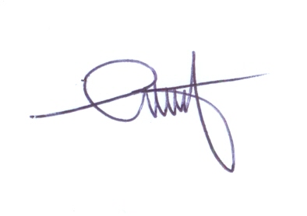
Signed:
In the capacity of MANAGING DIRECTOR]
Name: SAM. D. ANSONG
Duly authorized to sign the bid for and on behalf of: BEAUTIFUL CREATIONS LTD

Dated on 19th day of February, 2026.

